HomeStart Closet Request:
Student’s basic info …………………….
Morgantown address:
Items requested:
Linens:
Sheet set: Please indicate your bed size ☐Twin ☐ Twin XL ☐Full ☐Queen ☐King
Blanket: Please indicate your bed size ☐Twin ☐ Twin XL ☐Full ☐Queen ☐King
Comforter: Please indicate your bed size ☐Twin ☐ Twin XL ☐Full ☐Queen ☐King
☐Pillow
☐Towel
☐Washcloth
☐Bath mat
☐Shower curtain
☐Table cloth

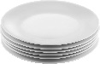
Table settings:
Plates: ☐Small ☐Salad ☐Large
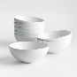
Bowls: ☐Small ☐Med ☐Large
☐Serving bowl
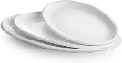
☐Serving Dish
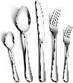
☐Cutlery/flatware (knife, fork, spoons)
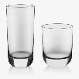
Glasses: ☐Small ☐Med ☐Large ☐Wineglass

☐Mug
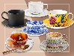
☐Tea cups/saucers

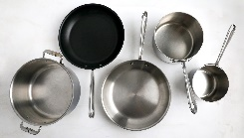
Kitchen Items
Pots: ☐Small ☐Med ☐Large
Frypan/Skillet: ☐Small ☐Med ☐Large ☐Stewpan
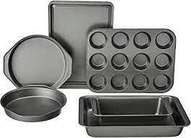
Bakeware: ☐Cookie sheets ☐Muffin tins ☐Cake pans ☐Loaf pans
☐Pizza pan
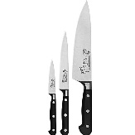
Kitchen knives: ☐Paring ☐Med chef’s ☐Large chef’s

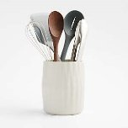
☐Kitchen spoons, spatulas, etc.
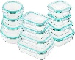
☐Food Storage containers
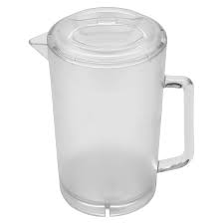
☐Jugs/Pitchers

